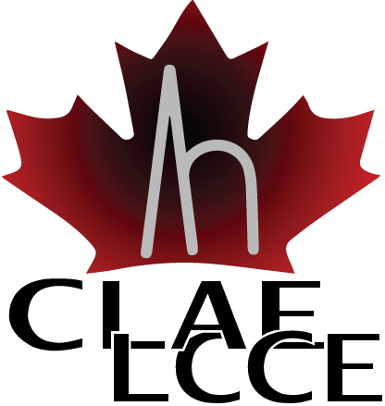

Junior Investigator Award

The CLAE is pleased to announce the call for the 2019 Junior Investigator Award.

This award honours a CLAE member within five years of their first academic appointment for outstanding research contributions in epilepsy. Both the nominee and the nominator must be CLAE members in good standing.

The following will be considered when evaluating the nominees:
- Other early career awards
- Peer-reviewed funding as a junior investigator
- Publication record (especially since his/her appointment as a faculty/academic member)
- Leadership in the field (invited speaker/moderator, clinical activities, public health, commercialization)
- Professional activities (committees, review of manuscripts, review of grants/awards)
- Supervisory activities/graduate committees/teaching activities
- Nomination letter
Submission deadline for nomination is Monday August 19, 2019. Nomination package must include:
- A letter of recommendation (maximum 2 pages) outlining why the nominee is deserving of this award.
- Nominee’s curriculum vitae (CV)
- Nomination form

Junior Investigator Award Nomination Form

Name of Nominee:
Institution:
Mailing Address:
City | Province |  | Postal Code
Phone | Fax
Email Address
Name of Nominator:
Institution:
Mailing Address:
City | Province |  | Postal Code
Phone | Fax
Email Address

Please send the completed nomination form with required attachments to: Dr. Francois Dubeau at clae@secretariatcentral.com.

